**MINISTRY OF EDUCATION AND TRAINING**

**FPT UNIVERSITY**

Capstone Project Document

**Q & A Platform for Educators**

|  |  |
| --- | --- |
| **Group 11** | |
| **Group members** | Kha Hoàng Minh – Team Leader – SE60979  Trương Như Khang – Team Member – SE60992  Trần Đìng Thi – Team Member – SE61137  Tạ Đức Tùng – Team Member – 60416 |
| **Supervisor** | Nguyễn Huy Hùng |
| **Ext. Supervisor** | N/A |
| **Capstone Project code** | QAPE |

-Ho Chi Minh City, May 11 2015-

*This page is intentionally left blank*

# Table of Contents

Table of Contents 3

List of Tables 3

List of Figures 4

Definitions, Acronyms, and Abbreviations 4

A. Report No. 1 Introduction 5

1. Project Information 5

2. Introduction 5

3. Current Situation 5

4. Problem Definition 5

5. Proposed Solution 6

5.1 Feature functions 6

5.2 Advantages and disadvantages 6

6. Functional Requirements 6

7. Role and Responsibility 7

B. Report No.2 Software Project Management Plan 8

1. Problem Definition 8

1.1 Name of this Capstone Project 8

1.2 Problem Abstract 8

1.3 Project Overview 8

2. Project organization 10

2.1 Software Process Model 10

2.2 Roles and responsibilities 11

2.3 Tools and Techniques 11

3. Project Management Plan 12

3.1 Product Backlog 12

3.2 Sprint Backlog 12

3.3 All Meeting Minutes 13

4. Coding Convention 13

C. Report No. 3 Software Requirement Specification 14

# List of Tables

Table 1: Definitions 4

Table 2: Roles and Responsibilities 7

Table 3 Current Situation 8

Table 4: Hardware Requirement for Server 10

Table 5: Roles and Responsibilities Details 11

Table 6: Product Backlog Detail 12

Table 7: Sprint 1 13

# List of Figures

Figure 1: Scrum Development Model 10

# Definitions, Acronyms, and Abbreviations

|  |  |
| --- | --- |
| **Name** | **Definition** |
| QAPE | Q & A Platform for Educators |

Table 1: Definitions

# Report No. 1 Introduction

## Project Information

* Project name: **Q&A Platform for Educators**
* Project Code: **QAPT11**
* Product Type: **Web Application**
* Start Date: **May 11th, 2015**
* End Date: **August 11th, 2015**

## Introduction

Nowadays, the development of internet and information technology led to the dramatic increase in trend of studying online. More and more information together with limited school time make having a website that supports studying is needed.

This project is a Q&A Web application where students and teachers can exchange information and other educational materials. Students can learn more things about the subject from posts of teachers or find the answers from other people.

## Current Situation

There is a lot of popular Q&A websites like Quora, Yahoo! Answers, Stack Overflow… People can post threads or answer the questions pretty easy using its account or connect to another account. These sites also have rating system for questions and responses in order to rate users as well.

Quora is rated as the best Q&A websites where you can find the answer for your question from real doctors, lawyers, chefs, engineers and more.

Yahoo! Answer is such as a longstanding Q&A website that everyone can join a thread and answer their question. The response will be awarded 10 points if the rate is highly recommended or 2 points if the rate is lower.

Stack Overflow is a Q&A websites for IT people with a lot of the professional and enthusiasm users. You can post a thread and wait responses from a lot of experienced programmers.

## Problem Definition

Most of Q&A problems are about the rewards of their good contributions. Somebody complained they should deserve better.

Quora and Yahoo! Answer are known as the Q&A famous website but their objects are about a lot of different issues in life. These websites doesn’t only focus on education so that students and teachers will be difficult for sharing their knowledge. Spamming questions are also problems of them. On the other hand, Stack Overflow only focuses on programing rather than diversifying subjects. All of them do not yet support the true studying environment.

## Proposed Solution

We suggest developing a Q&A website that focuses on studying. This website is such as a university in reality that includes many classes, teachers and students. It supports teachers share their additional lectures because of lacking of time. It also helps students ask self-confidently because some of them feel shy when asking in school.

### **Feature functions**

* Teachers have their classes with lectures and students. They can share additional lectures and studying materials, invites students join their classes. They also can invite other teachers together discuss about lectures or question.
* Students can ask about not yet understanding issues. They also join in classes to learn additional subject, follow their favorite teachers and manage studying material that uploaded by teachers.

### Advantages and disadvantages

The advantages and disadvantages of the proposed solution:

* Advantage:
* Teachers can upload their studying material (.doc, .pdf…) and students can manage it online.
* By supporting real time notification and discussion, students can imagine this website as the university with many classes, teachers and friends. They will feel free to ask anything.
* Users will have their right answers faster than they do on their own. That leads to learn better in real classes.
* System has a variety of categories that is better than Stack Overflow but it is not a mess such as Quora or Yahoo! Answers.
* Disadvantage:
* System do not support the users suggest teacher to join threads to answer the questions.
* Cost time waiting to approve to join a class.

## Functional Requirements

Function requirements of the system are listed as below:

**For Teachers:**

* Create classes.
* Create a post. Post types include: articles, questions, answer, and upload material.
* Invite other teachers to answer questions in the classes.
* Invite students to join the discussion in a class.
* Track students’ questions to see which topics a student is less known about.
* Support real time notification.
* Support real time in discussion.

**For Students:**

* Create a post: articles, questions, answer.
* Manage learning materials: allowing students to create folders to store different kinds of studying documents.
* Support real time notification.
* Support real time in discussion.
* Follow a teacher.
* Send a request to join in a teacher’s class.
* Support an easy way to add mathematic equation, code highlighting besides other normal text formatting for editor.
* Suggest related posts.

## Role and Responsibility

|  |  |  |  |  |
| --- | --- | --- | --- | --- |
| **No** | **Full Name** | **Role** | **Position** | **Contact** |
| **1** | Nguyễn Huy Hùng | Project Manager | Instructor | HungNH@fpt.edu.vn |
| **2** | Kha Hoàng Minh | Developer | Leader | MinhKHSE60979@fpt.edu.vn |
| **3** | Trương Như Khang | Developer | Member | KhangTNSE60992@fpt.edu.vn |
| **4** | Trần Đình Thi | Developer | Member | ThiTDSE61137@fpt.edu.vn |
| **5** | Tạ Đức Tùng | Developer | Member | TùngTD60416@fpt.edu.vn |

Table 2: Roles and Responsibilities

# Report No.2 Software Project Management Plan

## Problem Definition



### Name of this Capstone Project

* Q&A Platform for Educators (QAPE)

### Problem Abstract

Nowadays, in almost schools and university, the level of exchange knowledge between students and teachers are not much. A result of learning and teaching has not reached the highest efficiency with the following reasons:

Teaching hours of pretty little, much knowledge so that teachers cannot answer all questions of students during class, students fell shy to ask about their problems are not understood.

So building online Q&A system is urgently needed employment in the current educational context. This system will help teachers and students interact with each other through an application Website. Teachers can create their own classes are teaching on the Website and allow their student can join and post all question in that. Teacher can answer of student or invites another teacher can join and answer that question. They also can upload material and document for students that help them understand clearly the problem they do not understand.

.

### Project Overview

#### Current Situation

|  |  |  |
| --- | --- | --- |
| Website | Advantages | Disadvantages |
| Quora.com | -Can get answer by a prof.  -There are more Category  -User can edit question and edit answer from other user. | -Too much Category  -Everyone can answer question.  -Hard to find old answer.  -There is not real time discussion. Answer only. |
| Yahoo! Answer | -Can best answer by rating point  -Can ask everything: travel, book, films, social…. | -Everyone can answer question.  -No good interface design (too much word) |
| Stack Overflow | -Always pop Google search.  -So much data and load fast. | -No good design interface.  -There is not Category.  -There are much Basic question. |

Table 3 Current Situation

#### The Proposed System

From above disadvantages, this project is going to build a website that help teacher and student can communicate with each other easier and can get the answer from who what they want.

#### Website

**For Teachers:**

Create classes

Create a post. Post types include: articles, questions, answer, and upload material

Invite other teachers to answer questions in the classes

Invite students to join the discussion in a class

Track students’ questions to see which topics a student is less known about

Real time notification

Real time in discussion

**For Students:**

Create a post: articles, questions, answer

Manage learning materials: allowing students to create folders to store different kinds of studying documents.

Real time notification

Real time in discussion

Follow a teacher

Send a request to join in a teacher’s class.

Note: the editor must support an easy way to add mathematic equation, code highlighting besides other normal text formatting.

Suggest related posts

#### Boundaries of the System

This system is a Web application that helps student and teacher communicate with each other by Question and Answer.

There are three type of account: Student, Teacher, and Admin. They have different features.

#### Development Environment

##### Hardware requirements

**For server**

|  |  |  |
| --- | --- | --- |
| Windows | Minimum Requirements | Recommended |
| Internet Connection | Cable, Wi-Fi (4 Mbps) | Cable, Wi-Fi (8 Mbps) |
| Operating System | Window Server 2008 | Window Server 2008 |
| Computer Processor | Intel® Xeon ® 1.4GHz | Intel® Xeon ® Quad Core  (12M Cache, 2.50 GHz) |
| Computer Memory | 1GB RAM | 2GB or more |

Table 4: Hardware Requirement for Server

##### Software requirements

* Handle Products and sprints backlog: MS Excel 2013.
* Implement Website and service: IntelliJ v13.1.6.
* Create and manage database for system: MySQL v5.6.24 and MySQL Workbench v6.6.3.
* Source control: Github.
* Create models and diagrams: Software Ideas Modeler.
* Communicate and meeting: Skype 7.0 and Google mail.
* System and platform development: Window 7.

## Project organization

### Software Process Model

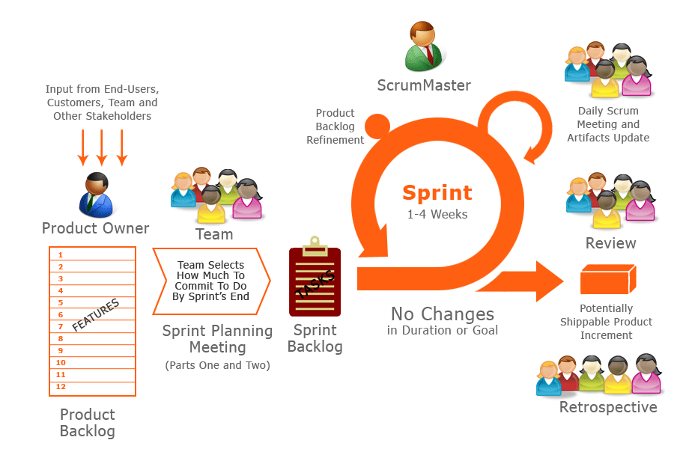

Figure 1: Scrum Development Model*

Because of the project characteristics, we decide to make progress in series of sprints which are time boxed iterations in one week. At the beginning of one sprint, through sprint planning meeting, all team members will discuss together to define sprint backlog which is suitable to be completed within a week. Daily meeting and online conference are used to manage all activities and issues troubleshoot. At the end of sprint, product owner and developer team will review completed product to figuring out the necessary changes for products.

*Reference from http://www.hanoiscrum.net

### Roles and responsibilities

|  |  |  |  |
| --- | --- | --- | --- |
| **No** | **Full name** | **Role in Group** | **Responsibilities** |
| **1** | Nguyễn Huy Hùng | Scrum Master/Product Owner | * Specify user requirement * Control the development process * Give out technique and business analysis support |
| **2** | Kha Hoàng Minh | Team Leader, BA, DEV, Tester | * Managing process * Designing database * Clarifying requirements * Prepare documents * GUI Design * Create test plan * Coding * Testing |
| **3** | Trương Như Khang | Team Member, BA, DEV, Tester | * Designing database * Clarifying requirements * Prepare documents * GUI Design * Create test plan * Coding * Testing |
| **4** | Trần Đình Thi | DEV | * Prepare documents * GUI Design * Create test plan * Coding * Testing |
| **5** | Tạ Đức Tùng | DEV | * Prepare documents * GUI Design * Create test plan * Coding * Testing |

Table 5: Roles and Responsibilities Details

### Tools and Techniques

- Front-end technologies: HTML5, CSS3, JavaScript, jQuery, AJAX.

- Back-end technologies:

+Website: Java

+Framework: Spring.

- Web Server: Installed Tomcat 7.0.61.

- Database Management System: MySQL 5.6.

## Project Management Plan

### Product Backlog

|  |  |  |  |
| --- | --- | --- | --- |
| **Project: Q&A Platform for Educators** | | | |
|
| **ID** | **Function** | **Description** | **Added Sprint** |
| 1 | Register | Registering to become member of website |  |
| 2 | Login/Logout | Accessing the account to use their features |  |
| 3 | Get forgotten password | Resetting password if forgetting |  |
| 4 | Edit profile | Users edit their profile |  |
| 5 | Create class | Teachers create class for student's joining |  |
| 6 | Create article, question, answer | User post an article, ask a question or answer a question |  |
| 7 | Upload material | Teachers upload their studying documents |  |
| 8 | Invite teacher | Teachers invite other teachers to answer a question on |  |
| 9 | Invite student | Teachers invite students to join the discussion in class |  |
| 10 | Accept/Deny an invitation | Users accept/deny teachers' invitation |  |
| 11 | Accept/Deny a request | Teachers accept/deny a joining request from student |  |
| 12 | Track student | Teachers track students’ questions to see which topics a student is less known about |  |
| 13 | Manage post | Users manage their post (edit, remove post), Admin only can remove post. |  |
| 14 | Manage class | Teachers manage students in their class |  |
| 15 | Real time notify | System support real time notification when followed teachers have new posts or posts have new reply |  |
| 16 | Real time discuss | New answers or replies will show at real time without refreshing page |  |
| 17 | Manage learning materials | Students to create folders to store different kinds of studying documents |  |
| 18 | Follow teacher | Students follow their favorite teachers |  |
| 19 | Send a request | Students send a request to join in a teacher’s class. |  |
| 20 | Suggest related post | System suggest related posts (related articles, related questions) for users |  |
| 21 | Search | Users search posts or other users |  |
| 22 | Manage users | Admin can ban/unban users |  |

Table 6: Product Backlog Detail

### Sprint Backlog

#### Sprint 1

|  |  |  |  |
| --- | --- | --- | --- |
| **No** | **Task** | **Implementer** | **Estimated hours** |
| 1 | Design homepage | MinhKH | 10 |
| 2 | Design register page | ThiTD | 6 |
| 3 | Design login form | ThiTD | 6 |
| 4 | Design get forget password page | ThiTD | 6 |
| 5 | Design student dashboard | TungTD | 8 |
| 6 | Design teacher dashboard | TungTD | 8 |
| 7 | Design admin dashboard | TungTD | 8 |
| 8 | Report 1 | ThiTD | 4 |
| 9 | Review report 1 | MinhKH | 3 |
| 10 | Setup environment turorial | KhangTN | 8 |
| 11 | Create overall use-case | KhangTN | 15 |
| 12 | Create guest use-cases | ThiTD | 10 |
| 12 | Create ERD | MinhKH | 12 |
| 13 | Create System Architectural Design | KhangTN | 10 |
| 14 | Report 2 | TungTD | 8 |
| 15 | Review report 2 | MinhKH | 3 |

Table 7: Sprint 1

### All Meeting Minutes

Place at Meeting Minute folder in Github.

## Coding Convention

Use Java coding convention to develop website.

Summary:

Naming Convention:

Use camel case for both variable and function name.

Use Pascal case for class name.

Indentation:

Avoid lines longer than 80 characters, since they are not handled well by many terminals and tools.

Declaration:

One declaration per line is recommended since it encourages commenting.

In absolutely no case should variables and functions be declared on the same line.

Do not put different types on the same line.

Code Examples:

Follow “Code Conventions for the Java TM Programming Language, by Sun Microsystems, rev April 20, 1999”.

<http://www.oracle.com/technetwork/java/codeconventions-150003.pdf>

# Report No. 3 Software Requirement Specification